**Vector Calculus Homework (20 Points)**

(jas Vector Calculus HW.docx 10/14/2025)

Use units and clearly label answers using 3 or 4 significant digits where appropriate. **Show your work** so that if necessary partial credit can be awarded.

1. Given that the scalar A = sin(x), determine the expression for , using rectangular coordinates, remembering is a vector. (2 Points.)
2. Given the vector **A** = , derive the expression for including the necessary steps, using spherical coordinates. (2 Points.)
3. Derive by hand the expression for the divergence of the vector **A** = using Cartesian coordinates, including the necessary steps (2 points). Then evaluate your expression at the point (1, 1, 1) (1 point). (3 points total.)
4. Using the MATLAB symbolic capability along with the **divergence**() function, determine the symbolic expression for the divergence of the vector **A** = using Cartesian coordinates, then evaluate the expression at the point (1, 1, 1). **Include your resulting MATLAB code below, along with the MATLAB output for both the symbolic expression (2 points) and the numeric result at the point (1, 1, 1)** **(1 point).** (3 points total.)

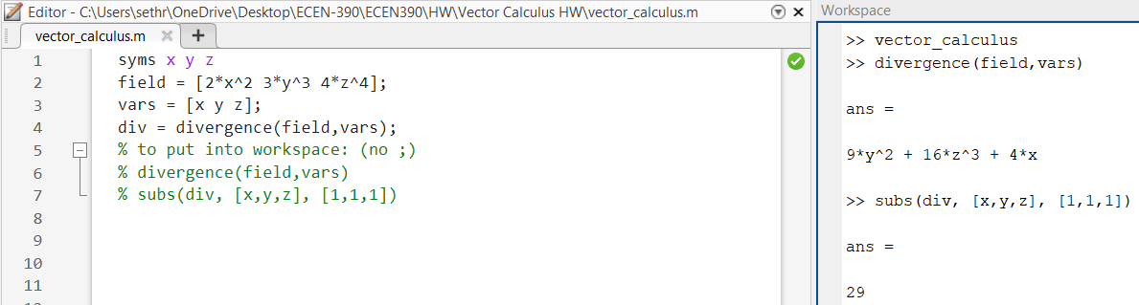

1. Derive by hand the expression for the curl of the vector **A** = using Cartesian coordinates, including the necessary steps (4 points). Then evaluate your expression at the point (1, 1, 1), remembering that the result is a vector. (2 points.)

(6 points total.)

=

=

1. Using the MATLAB symbolic capability along with the **curl**() function, determine the symbolic expression for the curl of the vector **A** = using Cartesian coordinates, then evaluate the expression at the point (1, 1, 1). **Include your resulting MATLAB code below, along with the MATLAB output for both the symbolic expression (2 points) and the numeric result at the point (1, 1, 1)** **(2 points.)** (4 points total.)

